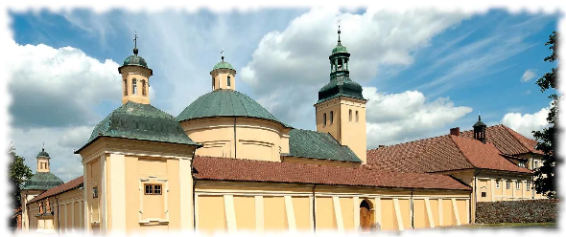
DOM PIELGRZYMA (KLASZTOR)
KLASZTOR KSIĘŻY MARIANÓW
11-106 KIWITY, Stoczek Klasztorny 30
tel. 897660911

www.stoczekklasztorny.pl e-mail: marianie@stoczek.pl

NR  POKOJU | ILOŚĆ MIEJSC | PRZYDZIAŁ POKOJU
3 | 3 | 1
3 | 3 | 2
3 | 3 | 3
4 | 2 | 4
4 | 2 | 5
5 | 2 | 6
5 | 2 | 7
6 | 3 | 8
6 | 3 | 9
6 | 3 | 10
7 | 4 | 11
7 | 4 | 12
7 | 4 | 13
7 | 4 | 14
8 | 3 | 15
8 | 3 | 16
8 | 3 | 17
9 | 2 | 18
9 | 2 | 19
10 | 3 | 20
10 | 3 | 21
10 | 3 | 22
11 | 3 | 23
11 | 3 | 24
11 | 3 | 25
12 | 3 | 26
12 | 3 | 27
12 | 3 | 28
13 | 3 | 29
13 | 3 | 30
13 | 3 | 31
14 | 4 | 32
14 | 4 | 33
14 | 4 | 34
14 | 4 | 35
15 | 4 | 36
15 | 4 | 37
15 | 4 | 38
15 | 4 | 39
16 | 4 | 40
16 | 4 | 41
16 | 4 | 42
16 | 4 | 43
19 | 4 | 44
19 | 4 | 45
19 | 4 | 46
19 | 4 | 47
21 | 3 | 48
21 | 3 | 49
21 | 3 | 50
22 | 2 | 51
22 | 2 | 52
23 | 2 | 53
23 | 2 | 54
24 | 2 | 55
24 | 2 | 56
25 | 2 | 57
25 | 2 | 58
26 | 2 | 59
26 | 2 | 60
27 | 2 | 61
27 | 2 | 62

